03rd April 2019

**YOKOHAMA’s Support for Motor Sports in 2019**

YOKOHAMA today announced its plans for supporting motor sports events in 2019. The technology strategy outlined in Grand Design 2020 (GD2020), the three-year medium-term management plan implemented by the Company since 2018, positions participation in motor sports activities as crucial to YOKOHAMA’s effort to be at the vanguard of the development of new tyre technologies. In 2019, we therefore will once again be participating in a wide variety of events in Japan and around the globe, from the top-category races to grassroots races. In addition to supporting our pursuit of the most advanced technologies, our enthusiastic and active participation in motor sports enables us to contribute to the further development of the motor sports market. This release briefly introduces some of the main events YOKOHAMA will be participating in this year.

##### Formula Races

###### Japanese SUPER FORMULA Championship

YOKOHAMA tyres have been the control tyres for the Japanese SUPER FORMULA Championship since 2016. The 2019 races will feature a new machine design, the Dallara SF19, and YOKOHAMA’s ADVAN racing tyres have again been selected as the control tyre. As in 2018, we will be supplying tyres with ADVAN tyres with two specs—a medium-compound tyre and a soft-compound tyre. The ADVAN A005 will be used in races run on dry tracks and the ADVAN A006 will be used on wet tracks. This year’s sizes will be 270/620R13 for front tyres and 360/620R13 for rear tyres.

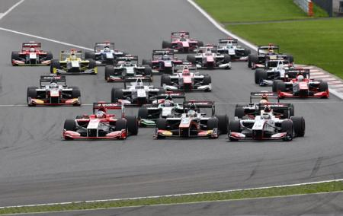

*Japanese SUPER FORMULA Championship (2018)*

###### Japanese Formula 3 Championship

We are proud to continue the relation begun in 2011 and supply our ADVAN racing tyres as the control tyre for the Japanese Formula 3 Championship, Japan’s longest continuously running motor racing series. We will supply the ADVAN A005 for use in races run on dry tracks and the ADVAN A006 for use on wet tracks. The supplied tyre sizes will be 200/50VR13 for front tyres and 240/45VR13 for rear tyres.



*Japanese Formula 3 Championship (2018)*

###### Super-FJ

Japan’s Super-FJ Formula racing series is a domestic regional championship established by the Japan Automobile Federation (JAF). The Super-FJ includes several highly competitive multi-race regional series held at the seven major circuits in Japan, from Tohoku in the north to Kyushu in the south. This year marks the tenth straight year since 2010 that we will be supplying ADVAN racing tyres for the Super-FJ races.

##### GT Touring Car Races

###### FIA World Touring Car Cup (WTCR)

The WTCR is a touring car race run under TCR technical regulations since 2018. YOKOHAMA was named the WTCR’s official tyre supplier for 2018–19 in recognition of our support for the series predecessor, the FIA World Touring Car Championship (WTCC), for 12 consecutive years from 2006. We will supply 250/660R18 size ADVAN A005 tyres for use on dry tracks and the same size ADVAN A006 for running on wet tracks during the series’ 10 planned races, with participating drivers first staring their engines in Morocco.



*WTCR (2018)*

###### TCR Japan Series

Our ADVAN racing tyres have been selected as the control tyre for the initial year of this new race series. YOKOHAMA’s selection as the official tyre supplier for this series as well as the WTCR also run under TCR technical regulations attests to racing officials’ high evaluation of YOKOHAMA tyres. The control tyres for the TCR Japan Series are the ADVAN A005 for dry tracks and the ADVAN A006 for wet tracks. The supplied tyre sizes will be 250/660R18.

###### Other Regional and National TCR Series

In addition to the WTCR and TCR Japan Series, we will again supply tyres for TCR regional racing series, such as TCR Europe, and such national series as TCR UK, TCR Iberico, and TCR Benelux —all of which used YOKOHAMA tyres in 2018. From this year, we also will supply for the TCR Germany and TCR Scandinavia series.

###### SUPER GT

SUPER GT races are contested in two classes, GT500 and GT300. GT500 is dominated by works teams from major automakers while GT300 teams tend to be more varied and individualistic. GT500 machine specifications are being brought in line with the regulations of the Deutsche Tourenwagen Masters (DTM, German Touring Car Masters) series, and since 2017 all racing teams are entering machines that meet the new regulations, including reduced downforce. GT300 races feature competition by a variety of cars made in Japan and overseas. The machines can broadly be divided into three types: (1) automakers’ production cars that meet the international FIA GT3 specifications, (2) unique JAF-GT machines, and (3) the so-called “Mother Chassis” group of machines.   
In the GT500 races, YOKOHAMA will be supporting the same three teams we sponsored in 2018—KONDO RACING’s Realize Corporation ADVAN GT-R, LEXUS TEAM WedsSport BANDOH's WedsSport ADVAN LC500, and TEAM MUGEN’s MOTUL MUGEN NSX-GT. We will also be supporting teams in the GT300 races.

The SUPER GT series will again consist of eight races, including one in Thailand. All the events are expected to thrill huge crowds of avid racing fans.

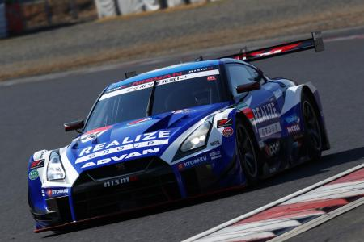

*Vehicle competing in SUPER GT／GT500 2019 series: KONDO RACING’s Realize Corporation ADVAN GT-R*

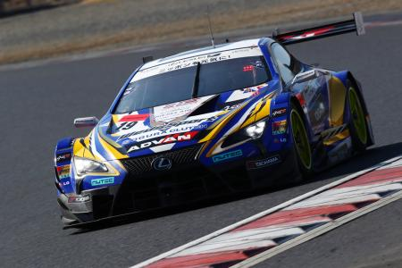

*Vehicle competing in SUPER GT／GT500 2019 series: LEXUS TEAM WedsSport BANDOH’s WedsSport ADVAN LC500*

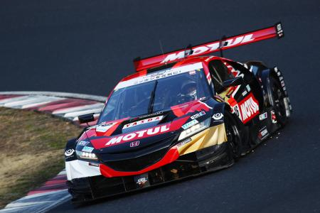

*Vehicle competing in SUPER GT／GT500 2019 series: TEAM MUGEN’s MOTUL MUGEN NSX-GT*

###### Nürburgring 24-Hour Endurance Race and VLN Endurance Championship

This year YOKOHAMA will supply teams competing in Nürburgring 24-Hour Endurance Race and VLN Endurance Championship at the Nürburgring course, widely considered to be one of the world’s most demanding race courses. We will support a number of teams, including KONDO RACING, which we are also supporting in SUPER GT races, as well as the Walkenhorst team racing in BMW machines. Supplied tires for both races will be the ADVAN A005 for use in dry conditions and the ADVAN A006 on wet tracks. YOKOHAMA will work closely with all supported teams as they seek to raise the championship trophy.

###### Other GT Races

YOKOHAMA will again supply its ADVAN racing tyres to participants in a number of GT races around the world, notably the Porsche GT3 Cup Challenge USA, the Porsche GT3 Cup Challenge Canada, and the Inter Proto Series in Japan.

##### Rally Series

###### Japanese Rally Championship

The Japanese Rally Championship will be contested over 10 races again in 2019. YOKOHAMA will supply teams with a range of tyres appropriate to the course conditions of each race, centering on ADVAN A052 and ADVAN A08B for races run on tarmac-paved roads and ADVAN A053 for gravel.   
In 2018, the team of Toshihiro Arai and Naoya Tanaka captured the JN-6 class series championship on YOKOHAMA tyres while Fumio Nutahara and Tadayoshi Sato finished third. YOKOHAMA-supported teams in other classes also achieved strong results, capturing second place in the JN-5, JN-4, and JN-1 classes and third place in the JN-2 class. In 2019, we look forward to again supporting teams vying for the championship in many classes. The Fumio Nutahara/Tadayoshi Sato team will compete again this year in a machine displaying the ADVAN colours.



*Toshihiro Arai/Naoya Tanaka team’s FUJI SUBARU AMS WRX STI (2018)*

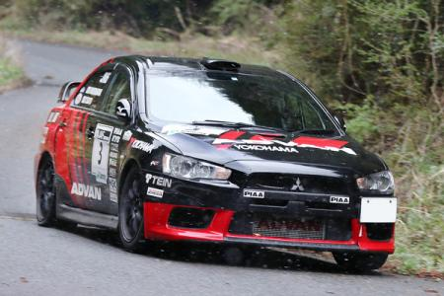

*Fumio Nutahara/Tadayoshi Sato team’s ADVAN-PIAA LANCER (2018)*

##### Other Races

###### Off-road races

YOKOHAMA again will supply its GEOLANDAR tyres for SUVs and pickup trucks to teams participating in off-road races around the world, including the desert races in North America and the Asia Cross Country Rally in Southeast Asia.

###### Kart races

YOKOHAMA again will support teams competing in the top-level OK class of the All Japan Karting Championship, the country’s premier kart racing series. The 2018 series resulted in the first series championship for a kart running on YOKOHAMA tyres. This year, four teams will outfit their karts with YOKOHAMA tyres, and we look forward to working with the teams

and drivers to capture another championship. In addition, YOKOHAMA will again support the FP-Junior Cadets class of the Japanese Junior Karting Championship by providing the control tyres. The ADVAN SLJ, which we began marketing in January 2018 specifically as a dry-surface tire for Cadets class karts, will again be supplied as the control tyre.  
Overseas, we again will supply the control tire for the Asian Karting Open Championship as well as tyres for circuit races in the Philippines and other countries.

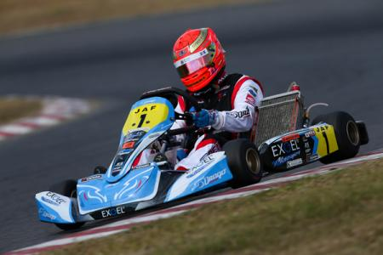

*2018 All-Japan Karting Championship’s OK class series champion*

YOKOHAMA continues to be an enthusiastic supporter of racing teams competing in events across all motor sports categories and in countries around the world. The data gathered from the use of YOKOHAMA tyres under the demanding conditions of motor sports contributes to our development of tyres for everyday drivers around the world. News updates and results of many of the races noted above will be posted on YOKOHAMA’s motor sports web site (<https://www.y-yokohama.com/cp/global/motorsports/>) as well as on the YOKOHAMA Channel on YouTube (<https://www.youtube.com/TheYokohamaRubber/>).

##### 2019 Motor Sports Calendar

###### Japanese SUPER FORMULA Championship

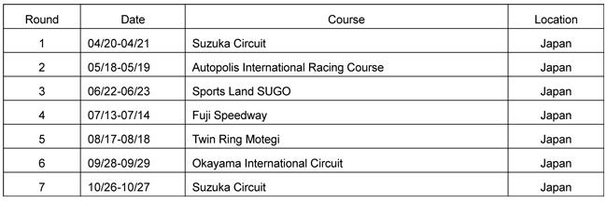

###### Japanese Formula 3 Championship

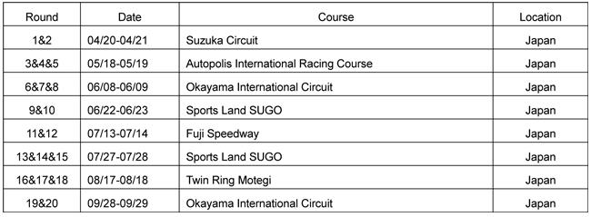

###### FIA World Touring Car Cup (WTCR)

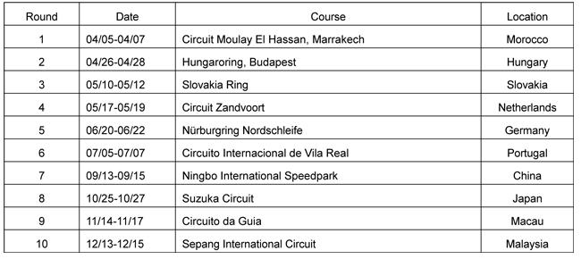

###### SUPER GT

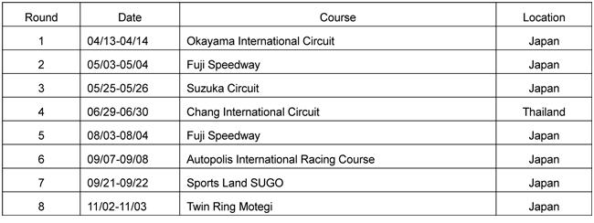

###### Japanese Rally Championship

